**Work with Production database**

When you have restored the production databases locally.

Open the connection string files. The production database names need to match those on the connectionstrings file. In addition, you will need to create a database user (in this case one user) that has has the username sagittarius and password sG81Ag!9. Because that is the user specified in the connectionstrings file.

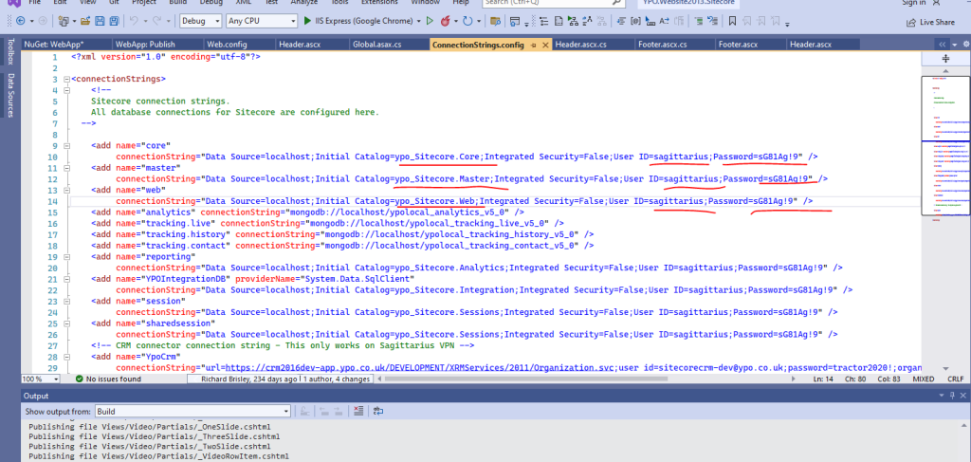

Create the user under Security folder

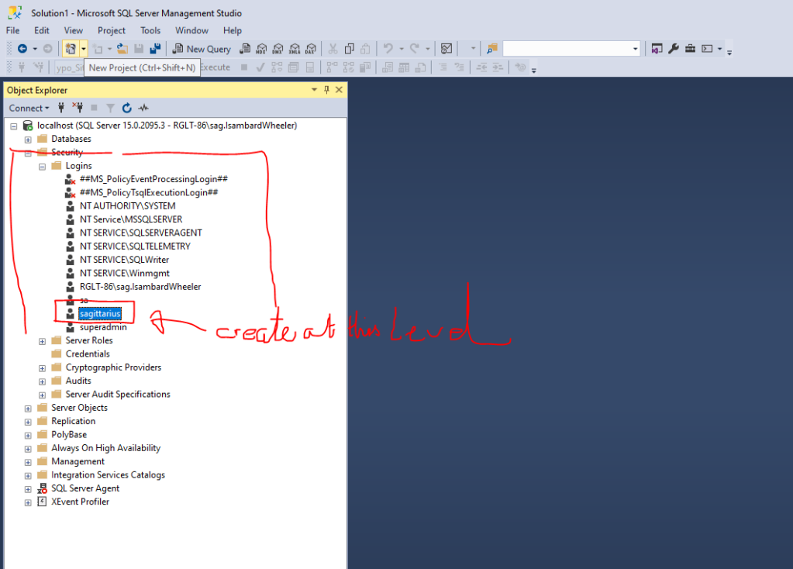

When you create User give sysadmin permissions.

Public permissions will be selected by default.



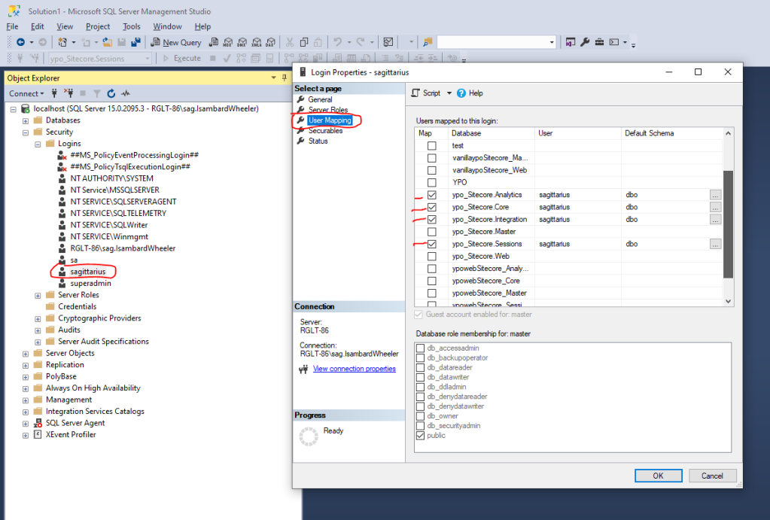

Error 5 Below

In the user Mapping section connect the user to the databases that it should interact with. These should be the same databases as specified in the connectionstrings file. I did not map the user I created to ypo_Sitecore.Master because the user sagittarius had been created locally to that Database (when I imported). This means that when I imported the ypo_Sitecore.Master database, it also imported the user associated with that database. In which case the users that were associated with the database.

